GOOGLE SHEET

Inserting record - https://app.workato.com/recipes/48045157-googlesheet#recipe

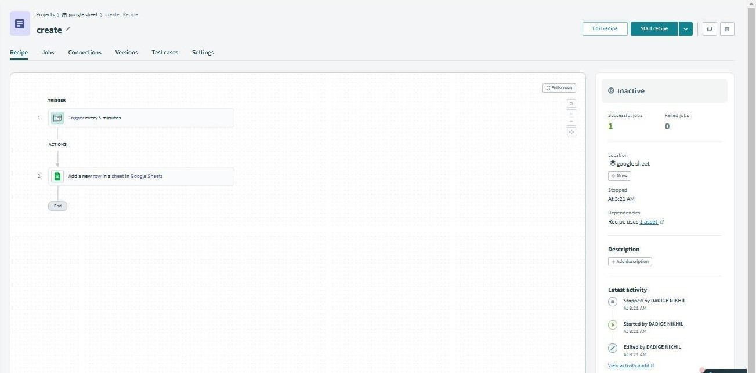

O/P

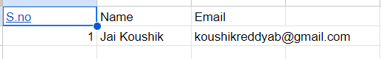

ERROR HANDLING :

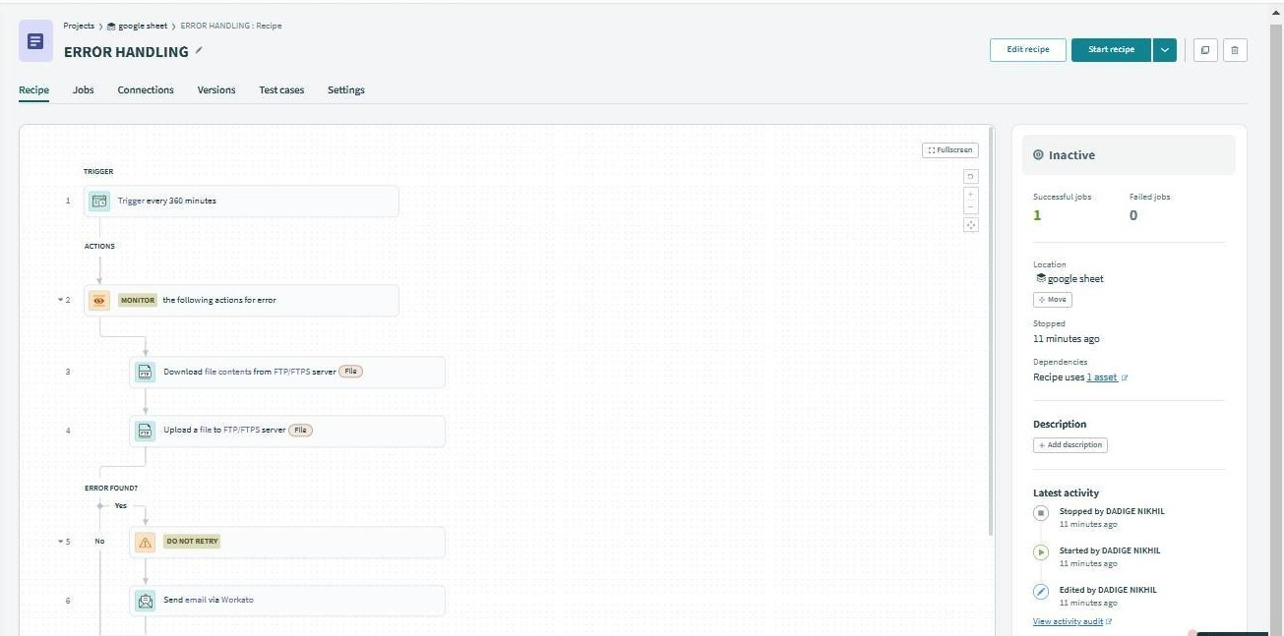

O/P

